# PROJECT REPORT TEMPLATE

# 1. INTRODUCTION

# 1.1 OVERVIEW

Governments use population forecasts at all levels (national, regional, city, international) for planning purposes, broadly defined. The basic purpose of government is to provide services for citizens, and this requires knowing how many people there will in the future, often broken down by age, sex and other characteristics, such as race and geography.[1](https://www.sciencedirect.com/science/article/pii/S0169207021001394" \l "fn1) Population forecasts are also widely used in the private sector for strategic planning, and by academics and other researchers, particularly in the health and social sciences.

# 1.2. PURPOSE

Population forecasts are used by governments and the private sector for planning, with horizons up to about three generations (around 2100) for different purposes. The traditional methods are deterministic using scenarios, but probabilistic forecasts are desired to get an idea of accuracy, assess changes, and make decisions involving risks. In a significant breakthrough, since 2015, the United Nations has issued probabilistic population forecasts for all countries using a [Bayesian](https://www.sciencedirect.com/topics/economics-econometrics-and-finance/bayesian) methodology that we review here. Assessment of the social cost of carbon relies on long-term forecasts of [carbon emissions](https://www.sciencedirect.com/topics/economics-econometrics-and-finance/greenhouse-gas-emissions), which in turn depend on even longer-range population and [economic forecasts](https://www.sciencedirect.com/topics/economics-econometrics-and-finance/economic-forecast), to 2300. We extend the UN method to very-long range population forecasts by combining the statistical approach with expert review and elicitation. While the world population is projected to grow for the rest of this century, it will likely stabilize in the 22nd century and decline in the 23rd cent.

**2. PROBLEM DEFINITION & DESIGN THINKING**

**2.1. EMPATHY MAP**

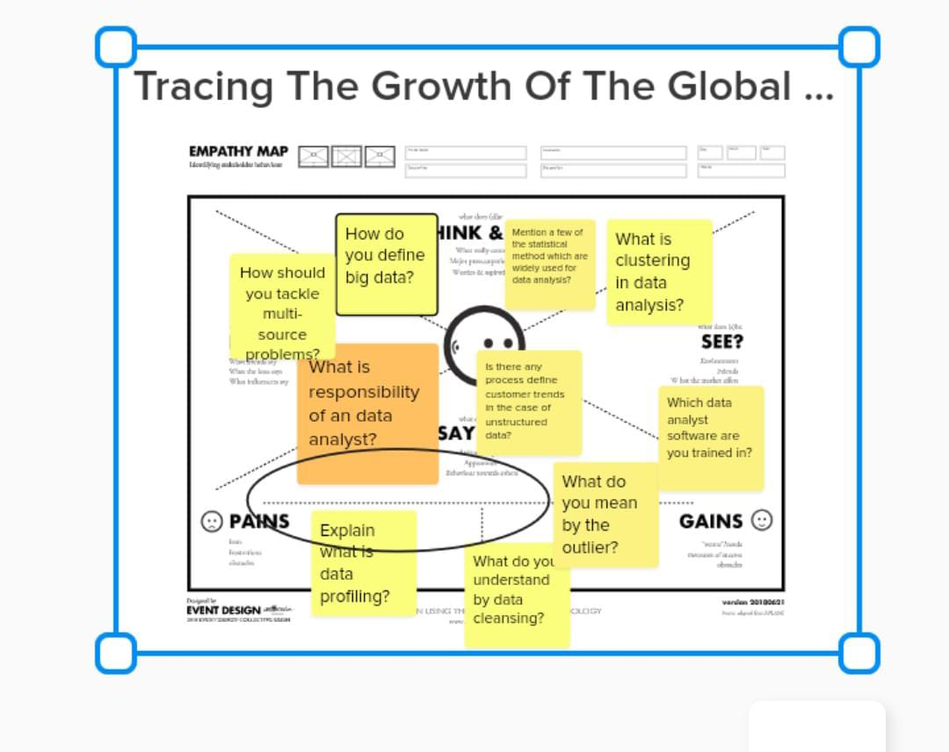

# 3. RESULT

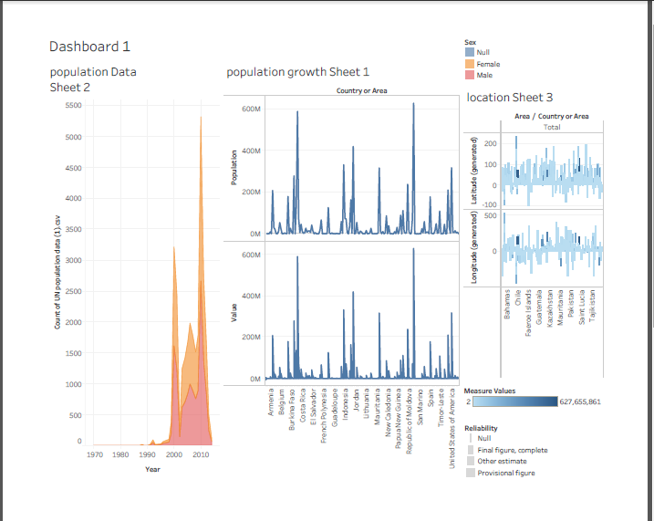

**4. ADVANTAGES & DISADVANTAGES**

**ADVANTAGES**

In the solution of any planning problem, the planner either makes an explicit forecast, or makes some implicit assumption about the population for which he is planning. "population" includes much more than mere numbers of people. The planner must know what kind of people live in his planning area, what types of lives they lead, and would like to lead, how long they will live, and how long they will reside in the particular area; and who will replace them when they move out or die; how many children they will have (and would like to have under different conditions), whether these children will live in the area, and many other factors.

Many communities have installed facilities which have become useless because predicated on faulty estimates of future population, or they have failed to install facilities where justified by future population. A common example of such errors is the newly constructed school in an area where the population is aging rather than being replaced by young, child-bearing families. Sewer systems have been expensively developed only to be later replaced because the population soon was double or triple what was anticipated for the area. Narrow streets have been later widened at great expense. On the other hand, land often has been overly zoned for commercial purposes in the expectation of a vast increase in population which did not materialize. Or land was zoned for potential capacities in some cities of whole state or even the entire population of the country. Prematurely subdivided land is plaguing many of our communities today.

**DISADVANTAGES**

Anticipating the numbers and characteristics of future population is very difficult. Since the planner is unable to fully foresee and therefore to predict future world social and economic conditions, he can only project what he thinks will happen to present trends in the future. He must make assumptions about the future, assumptions which may be outmoded or invalidated in a rapidly changing industrial society.

For the practising planner today there is another obstacle. The population analyst has generally been concerned with forecasting the future populations of whole countries, and diverse national trends tend to cancel out each other in the largeness of the figures. However, projection of population in small areas, such as county or city is a more difficult task, because an error in projection may not be balanced by another unforeseen event or influential factor, and because an error in projection may result in a variation important when compared to the small local total (although not important when compared to a national total). In addition, in- and out-migration for the local area must be projected; this is no easy task. This is especially true for populations of large cities where the major element of population change has been migration. This is also especially true of certain sections of the country — some West Coast communities have doubled or trebled their populations in less than a decade.

In spite of all the obstacles, none of which can be under-estimated, and all of which seem to announce the foolhardiness of any attempt, population projections must be made expertly enough so that the planner can perform his function planning for the future population of his area.

# 5. APPLICATIONS

In the solution of any planning problem, the planner either makes an explicit forecast, or makes some implicit assumption about the population for which he is planning. "Population" includes much more than mere numbers of people. The planner must know what kind of people live in his planning area, what types of lives they lead, and would like to lead, how long they will live, and how long they will reside in the particular area; and who will replace them when they move out or die; how many children they will have (and would like to have under different conditions), whether these children will live in the area, and many other factors.

# 6. CONCLUSION

It cannot be over-emphasized that there are many varied factors influencing birth rates, migrations, and to a lesser degree, death rates. Unfortunately, much of the research necessary to isolate these various factors and to appraise their effects remains to be done. The planner in forecasting future population for his area may seek the aid of a demographer especially trained in the technical study of population. However, the planner must work closely with the demographer to constantly relate planning considerations to statistical manipulations. The planner, with his knowledge of the area and study of its economic potentialities and his proposals for future densities (and distribution of these), has insights into the developmental pattern of a community, which the demographer lacks.

Population projections, like master plans, must be revised quite frequently. It has been suggested in this report that several alternative projections be made on the basis of different sets of assumptions..

# 7. FUTURE SCOPE

To forecast age-sex groupings it was assumed that the relationship they had established between Broome County and United States figures would continue. The Thompson and Whelpton predictions for age and sex groupings in the country were used for computed figures for Broome County. The assumption made in the latter method that similarity between county and national figures would continue is not to be recommended; there is no inherent reason why such a relationship should continue for another 20 years. A few years of atypical migration would invalidate the entire projection.

This same approach was used by the Flint, Michigan, study mentioned previously, wherein a relationship was found between trends in United States durable goods manufacturing employment and the Flint area labor force. Flint population figures were projected into the future on the basis of future national trends. Without knowing the reasons for this relationship one cannot assume its continuation in future years.